Declaring objects and give value of datatypes and print it

Workshop #3

Flutter Developer Bootcamp

# **Purpose**

This workshop demonstrates to introduce participants to fundamental programming concepts and data types in Dart.

**Problem**

In the given workshop demonstrates an essential concepts like data types, variables, and console output. They will learn to write basic Dart programs, handle various data types effectively, and use the print function for displaying information. There will object ‘a’ with the value of datatype string and it prints “string”, object ‘b’ with value of datatype int and it prints 10.You need to Declare object ‘c’, give value of data type double print it c = 0.1888

**How to Solve**

1. Checkout the workshop from Git Repo:

git clone -b <user-branch> <repo-URL>

1. Open the root folder inside VS Code
2. Open the root folder in terminal
3. Run the command dart run filename.dart
4. Variable Declaration and Initialization: Shows how to declare variables (String, int, double, bool) and assign initial values.
5. Double Variable: Initializes c as a double with value 0.1888 and prints it (print(c)).
6. Console Output: Uses the print function to display the values of variables to the console.
7. Go To File: <specific-file--method> à <method-name>, implement your logic.

**You will Achieve**

When you complete this workshop you will learn the following:

Methods and Functions Included**:**

* **main Function:**
* void main(List<String> args)
* Entry point of the Dart program where execution begins. Can handle command-line arguments (args) if provided.
* **print Function:**
* print(someVariable);
* Outputs the value of someVariable to the console. Useful for debugging and displaying program output.

# **Screenshots**

## **Before implementation (without printing hello world)**

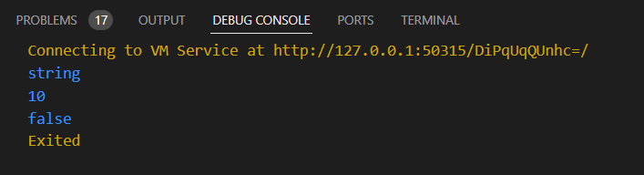

## **After implementation (with printing hello world)**

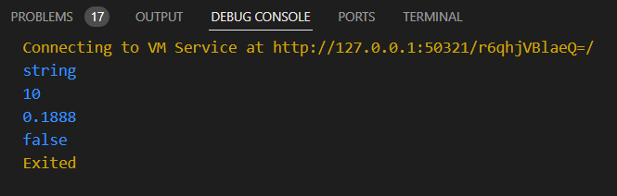

# **How to submit your workshop**

Push your project back to the same git branch using command:

<command name>

# **Happy Coding!**